**COMPUTER SCIENCE L300**

**GROUP 3**

**Final Project Demo Report**

**PROJECT DRSCRIPTION**

Overview: Our project aims to develop an e-commerce mobile application that provides customers with a seamless shopping experience. The application will be designed to run on both Android and iOS platforms and will offer a wide range of products in various categories. Users will be able to browse and purchase products, track their orders and interact with the customer support team through the application.

**FEATURES**

1. **USER REGISTRATION AND AUTHENTICATION:** The app will require users to register and create an account using their email or social media accounts. Users will be required to authenticate themselves through a verification process.

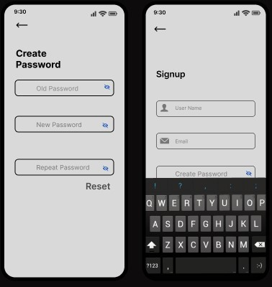

1. **PRODUCT CATALOGUE:** The application willoffer a wide range of products in various categories including electronics, fashion, home and beauty. Users will be able to browse and filter products based on their preferences and make purchases through the application.

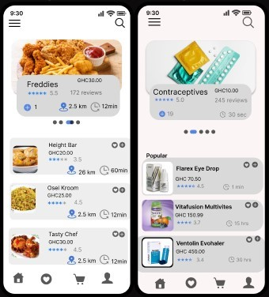

1. **WISH LIST:** Users will be able to create a Wish list of their favourite products and save them for future purchases.

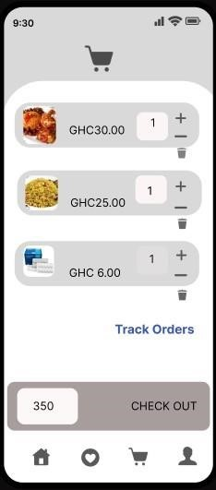

1. **RATINGS AND REVIEWS:** Ratings and review will allow users to be able to rate and review products they have purchased which will help other users make informed purchase decisions.

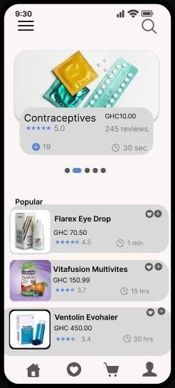

**STRENGTH OF THE APPLICATION**

* Convenient shopping: Users and customers of the application can shop and receive their orders without leaving their home, which increases convenience and accessibility.
* Personalization: The application can use customer data to provide personalizes recommendations, promotions, and deals based on their interest and previous purchase history.
* Increased sales: By offering an easy and accessible way for customers to shop and receive their orders, the application can increase sales and revenue for businesses.
* Improved customer engagement: The application also provides a direct line of communication with customers through push notifications and in-app messaging, which can help to increase customer engagement and loyalty.

**WEAKNESSES OF THE APPLICATION**

* Technical issues: The e-commerce application can experience technical issues, such as crashes or slow loading times, which can negatively impact the users experience and lead to customer frustration.
* Security concerns: The application can be vulnerable to security breaches, which can put customer data at risk and damage the reputation of the business.
* Compatibility issues: The application may not be compatible with all devices or operating systems which can limits their accessibility and reach.

**CONCLUSION**

Our e-commerce mobile application will provide users with a seamless shopping experience with a wide range of products, multiple payment options, and real-time order tracking. The application’s customer support feature will ensure that users receive timely assistance and support. The application’s social media integration and push notifications will keep users updated on new arrivals and promotions, making it a one-stop-venue for all their shopping needs.

**THE LINK TO THE PROJECT’S GITHUB REPOSITORY FOR THE APPLICATION**

[**https://github.com/EcommerceMobile/MobileApp**](https://github.com/EcommerceMobile/MobileApp)